N Northlake Way
from the railroad tracks east of Meridian Ave N to N 35th St
Wed. Oct 19 – Fri. Oct 21
9 AM to 3 PM
*Weather permitting
At the location and hours listed above:
- SDOT will grind and repave the street.
- All parking along the street will be restricted.
  - SDOT will place “NO PARKING” signs on the street three days before the work starts and these parking restrictions begin.
- The street will be closed to all traffic.
  - Arrangements can be made for special deliveries by contacting SDOT 48 hours in advance.
  - There will be no vehicle access to the entrances and exits to parking lots or parking garages on this section of N Northlake Way.
- Sidewalks and The Burke Gilman Trail will remain open.

Note: Another paving project will occur Mon. Oct 17 - Wed. Oct. 19 on N Northlake Way from Densmore Ave N to the railroad tracks just east of Meridian Ave N. During the Oct. 17 – Oct 19 paving project, N Northlake Way east of these railroad tracks will be open.

See other side for map.

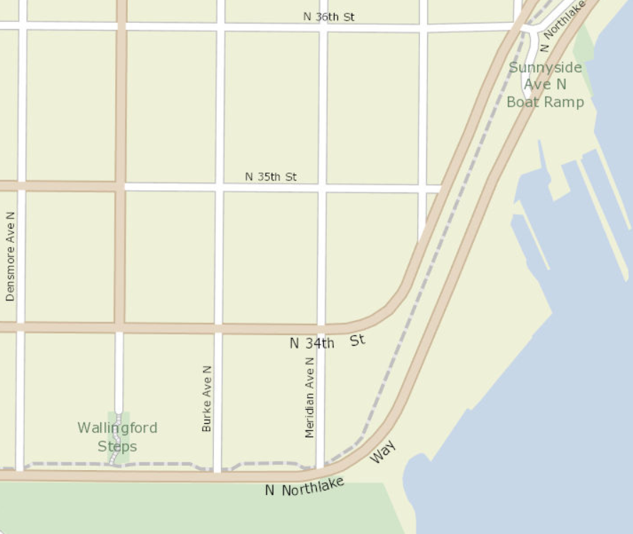

= area closed for repaving project

Thank you for your cooperation!

This project is part of SDOT’s Arterial Major Maintenance (AMM) program. AMM receives funding from the “Move Seattle” transportation levy passed by voters in 2015

October 2016

