N Northlake Way
from Densmore Ave N to the railroad tracks east of Meridian Ave N
Mon. Oct. 17 – Wed. Oct 19
9 AM to 3 PM
*Weather permitting
At the location and hours listed above:
- SDOT will grind and repave the street.
- All parking along the street will be restricted.
  - SDOT will place “NO PARKING” signs on the street three days before the work starts and these parking restrictions begin.
- The street will be closed to all traffic.
  - Arrangements can be made for special deliveries by contacting SDOT 48 hours in advance.
  - There will be no access to the entrances and exits to the Gas Works Park parking lot.
- The pedestrian entrance to Gas Works Park west of Densmore Ave N will remain open.
- Sidewalks and The Burke Gilman Trail will remain open.

Note: Another paving project will occur Wed. Oct. 19 – Fri. Oct. 21 on N Northlake Way from the railroad tracks just east of Meridian Ave N to N 35th St. N Northlake Way in front of Gas Works Park will be open during this second paving project.

See other side for map

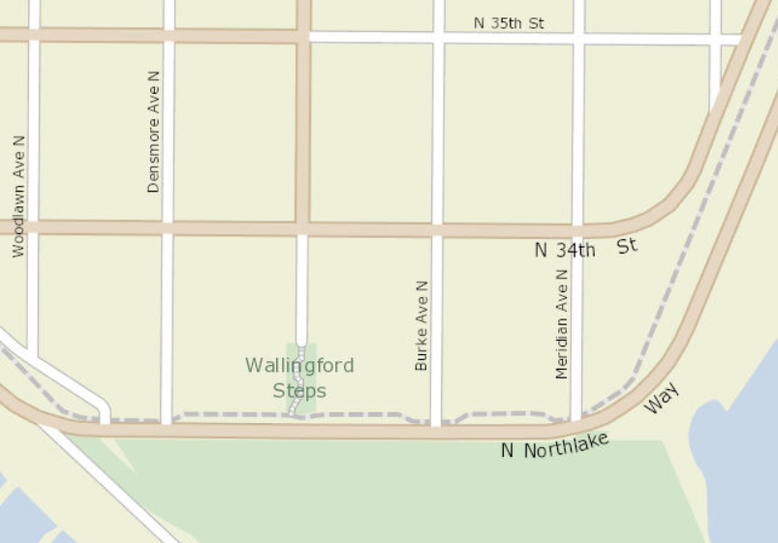

= area closed for repaving project

Thank you for your cooperation!

This project is part of SDOT’s Arterial Major Maintenance (AMM) program. AMM receives funding from the “Move Seattle” transportation levy passed by voters in 2015

October 2016

